SOFTWARE ENGINEERING LAB TASK 10

Class, Sequence and Collaboration Diagram for ATM

HU22CSEN0100999

Eshwar Deshmukh Chavan

**Understanding UML Diagrams: (Class, Sequence, and Collaboration Diagrams)**

**Introduction:**

* Designing a complex system (like an ATM or a university management system) needs a clear blueprint before coding.
* A blueprint shows how different parts interact, which is where UML diagrams come in.
* UML (Unified Modelling Language) diagrams help developers, designers, and stakeholders see the system’s structure and behavior early on.
* They ensure everyone understands the design, reducing confusion and streamlining development.
* This guide explores three essential UML diagrams using examples from an ATM System and a University System.

1. **Class Diagram** – Defines the system structure, listing classes, attributes, and relationships.
2. **Sequence Diagram** – Outlines how objects interact step by step over time.
3. **Collaboration Diagram** – Focuses on how objects communicate to complete tasks.

**Class Diagram – The Foundation of the System:**

* **What is a Class Diagram?**
  + It is like the blueprint of a system, showing which objects exist, what data they hold, and how they are connected.
  + **Example:** In an ATM system, there are classes such as Customer, ATM, Bank, and Transaction.
  + Likewise, a University system includes classes like Students, Teachers, Courses, and Admin.
* **Key Components of a Class Diagram:**
  + **Classes:** Drawn as rectangles divided into three parts:
    - **Class Name** (e.g., Student, ATM, Course)
    - **Attributes** (e.g., customer name, balance, course title)
    - **Methods** (functions the class performs, like enroll() or withdrawCash())
  + **Relationships:** Explain how classes work together:
    - **Association:** A general link (e.g., a Student enrolls in a Course).
    - **Inheritance (Generalization):** One class extends another (e.g., Savings Account is a type of Bank Account).
    - **Aggregation:** One class is part of another but can exist on its own (e.g., a University has many Courses).
    - **Composition:** A stronger form where one object cannot exist without the other (e.g., a Transaction is part of an ATM session).

**Example: ATM System :**

* **Main Classes & Their Roles:**
  + **Customer:** Stores details such as customer ID, name, and PIN.
  + **ATM:** Represents the machine with properties like ID, location, and balance.
  + **Bank:** Manages customer accounts and approves transactions.
  + **Transaction:** Records details like amount, date, and type of transaction.
* **How They Interact:**
  + A Customer uses the ATM to perform transactions.
  + The ATM connects with the Bank to verify the PIN and process withdrawals.
  + Each Transaction is recorded to ensure security and proper tracking.

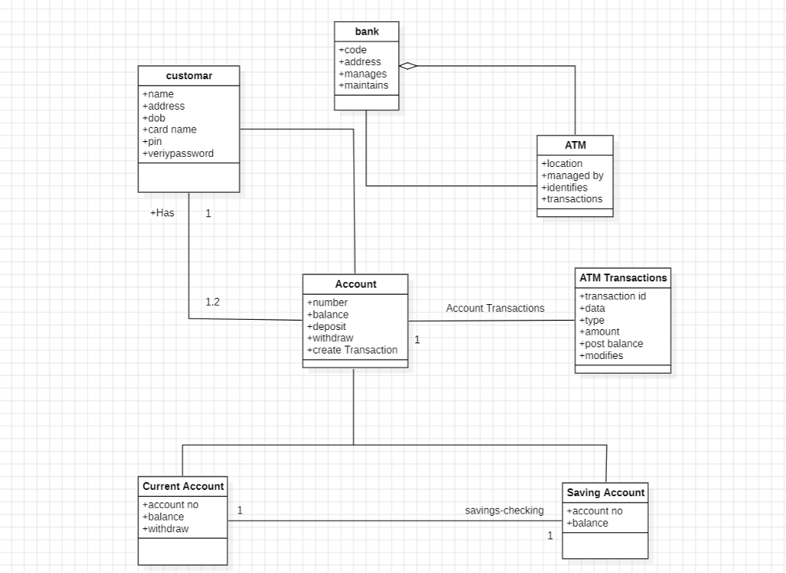

**Example: University System**

* **Main Classes & Their Roles:**
  1. **Student:** Holds details such as student ID, name, and email.
  2. **Teacher:** Manages subjects and assigns grades.
  3. **Course:** Stores course information like title, credits, and schedule.
  4. **Admin:** Oversees course offerings and system reports.
* **How They Interact:**
  1. Students enroll in Courses (Association).
  2. Teachers teach and grade Courses (Association).
  3. Admins monitor and modify Courses as needed (Aggregation).

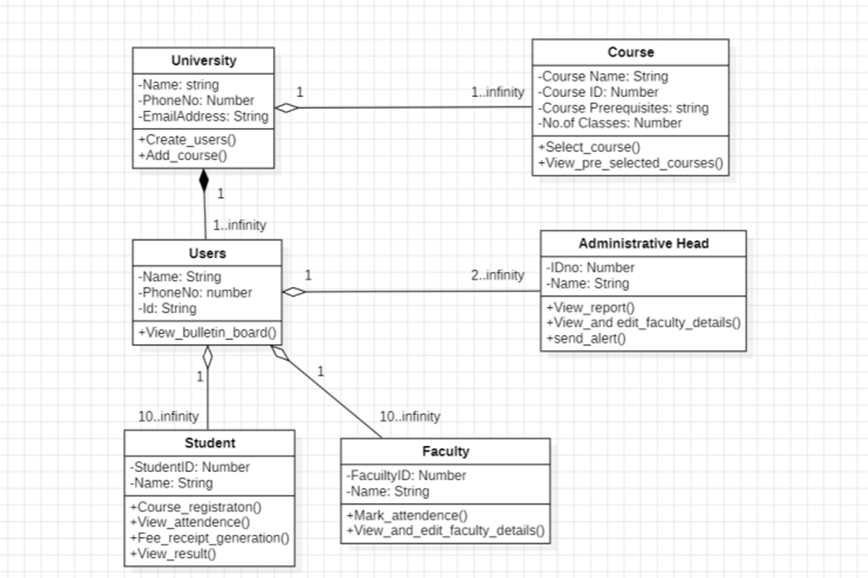

**Sequence Diagram – The Step-by-Step Flow of a System**

* **What is a Sequence Diagram?**
  + Think of it as a play script outlining the order of interactions in a system.
  + It helps you understand how a process unfolds over time.
  + For instance, an ATM process goes from inserting a card to dispensing cash.
  + Similarly, a University System shows steps from logging in to enrolling in courses.
* **Key Components:**
  + **Objects (Actors & System Components):** Represented as rectangles (e.g., Customer, ATM, University System).
  + **Lifelines:** Dotted vertical lines that indicate the duration an object is active.
  + **Messages:** Arrows showing function calls (solid lines) and responses (dashed lines).
  + **Activation Bars:** Highlight when an object is actively processing a request.
* **Example: ATM Sequence Diagram – How a Withdrawal Happens:**
  + Customer inserts the card.
  + ATM requests a PIN.
  + Customer enters the PIN.
  + ATM verifies the PIN with the Bank.
  + Bank sends back a valid/invalid response.
  + If valid, the ATM displays transaction options.
  + Customer selects "Withdraw Cash."
  + ATM requests approval from the Bank.
  + Bank approves the transaction.
  + ATM dispenses cash and prints a receipt.

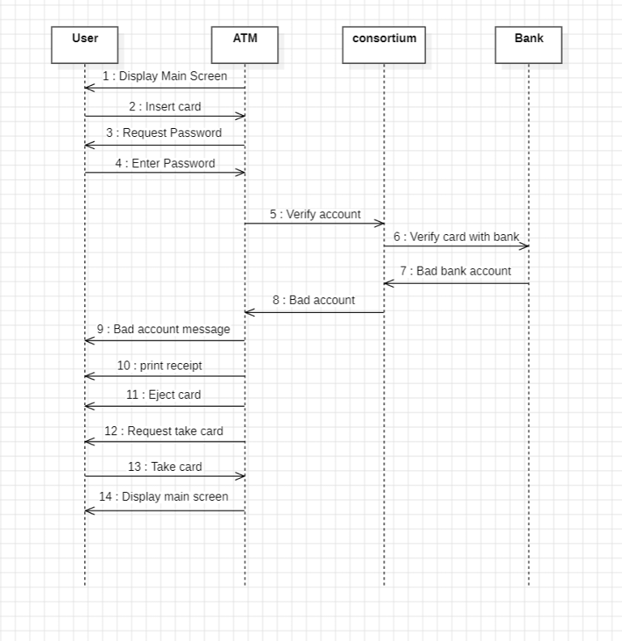

**Example: University Sequence Diagram – How Course Enrolment Happens**

1. Student logs into the University System.
2. System verifies the credentials.
3. If the credentials are valid, the System grants course access.
4. Student selects "Enrol in Course."
5. System checks if the course is available.
6. If available, the enrolment is confirmed.
7. Teacher enters grades.
8. Admin manages course offerings.

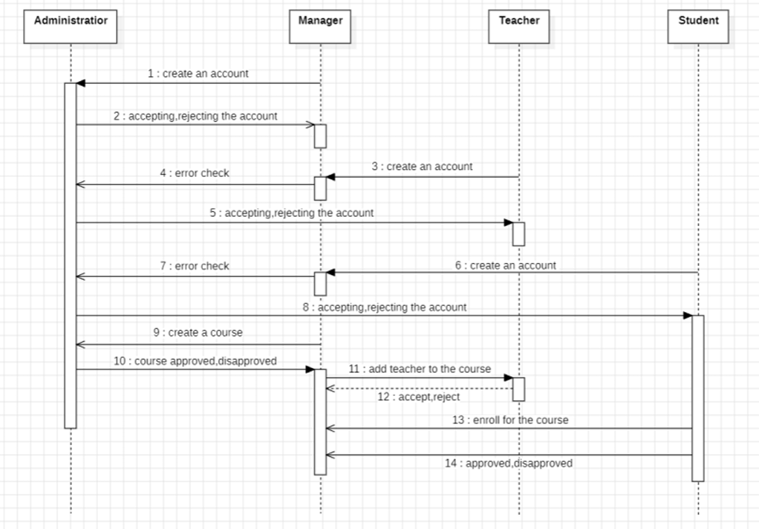

**Collaboration Diagram – How Objects Work Together**

* **What is a Collaboration Diagram?**
  + It shows how different parts of a system work together to complete a task.
  + Unlike Sequence Diagrams that focus on the order of events, Collaboration Diagrams highlight the relationships and communication between components.
* **Key Components:**
  + **Objects:**
    - Represented as rectangles, these are the main elements (e.g., Customer, ATM, Bank).
  + **Links:**
    - Lines connecting objects, indicating that they interact with each other.
  + **Messages:**
    - Numbered arrows along the links that show the order in which the communication happens.
* **Example: ATM Collaboration Diagram (From Document) – How ATM Components Interact:**
  + **Customer Action:** The Customer inserts their card into the ATM.
  + **PIN Request:** The ATM asks the Customer to enter their PIN.
  + **PIN Verification:** The ATM sends the entered PIN to the Bank for verification.
  + **Authentication Response:** The Bank sends back a response indicating if the PIN is valid.
  + **Transaction Selection:** The Customer selects a transaction (for example, withdrawing cash).
  + **Withdrawal Request:** The ATM sends a withdrawal request to the Bank.
  + **Approval:** The Bank approves the withdrawal request.
  + **Cash Dispense:** The ATM dispenses the cash.

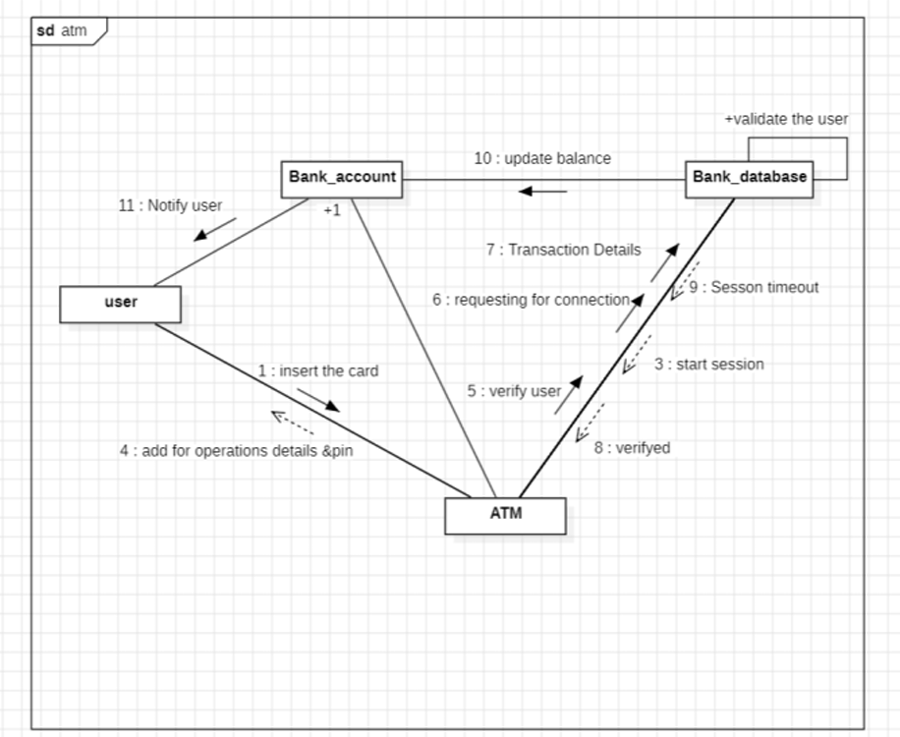

**Example: University Collaboration Diagram (From Document) – How System Components Interact**

1. A student logs into the University System.
2. The system verifies the student's credentials.
3. The student enrolls in a course.
4. The system checks if the course is available.
5. A teacher submits the student's grades.
6. An admin manages the courses.

